The Aoyama Tree
Los Angeles Historic Cultural Monument No. 920

Designated May 20, 2008

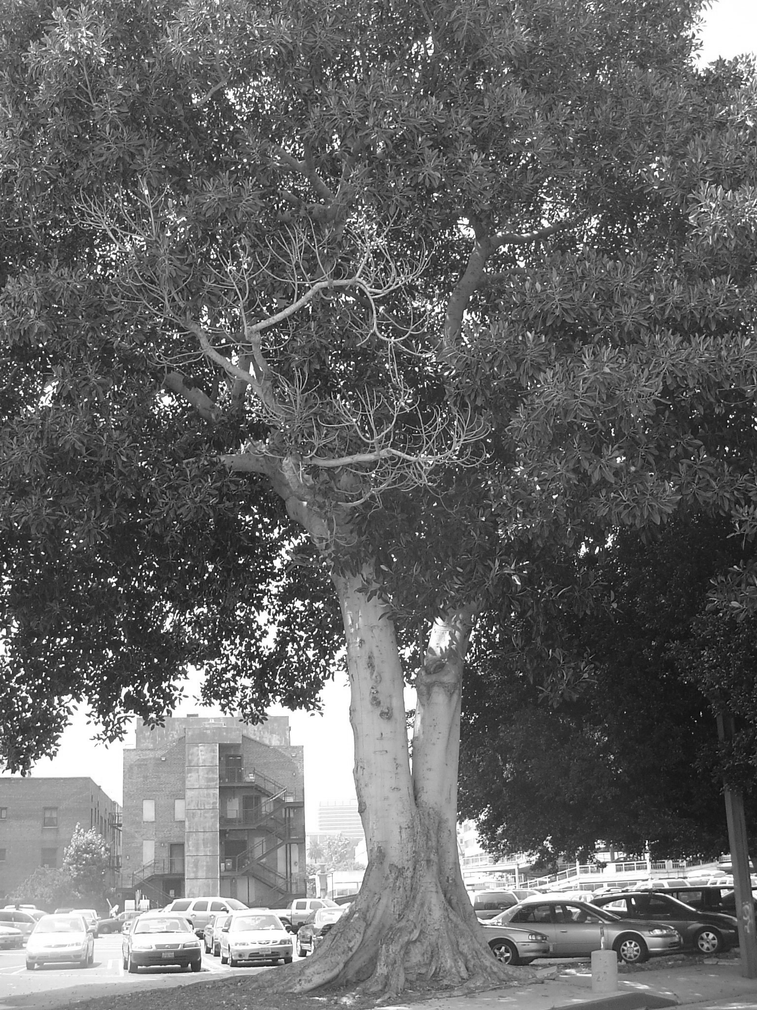
The Aoyama Tree, Historic Cultural Monument Number 920, is a 60 by 70 foot Moreton Bay Fig (Ficus macrophyllia) located on the City of Los Angeles-owned parking lot immediately north of the National Center for the Preservation of Democracy (a component of the Japanese American National Museum). The Aoyama Tree symbolizes the cultural and historical development of Buddhism and the Japanese American community in Los Angeles. This tree represents the founding of Koyasan Buddhist Temple in Little Tokyo, which is one of the oldest and largest Buddhist temples in Los Angeles.

Reverend Shutai Aoyama, who came to the United States in 1909, founded Koyasan Buddhist Temple. Reverend Aoyama labored alongside other Japanese immigrants on farms and railroads, and in shipyards, during which time he became increasingly aware of the workers’ need for support and spiritual guidance. In 1912, he started the Koyasan Daishi Mission in a small storefront on Commercial Street in Little Tokyo. In 1920, the temple moved to a wood-frame building at 133 North Central that had previously housed a Japanese restaurant and was owned by the Southern Pacific Railroad Company. The Moreton Bay Fig tree marks the location of the Koyasan Daishi Mission, which is no longer standing.
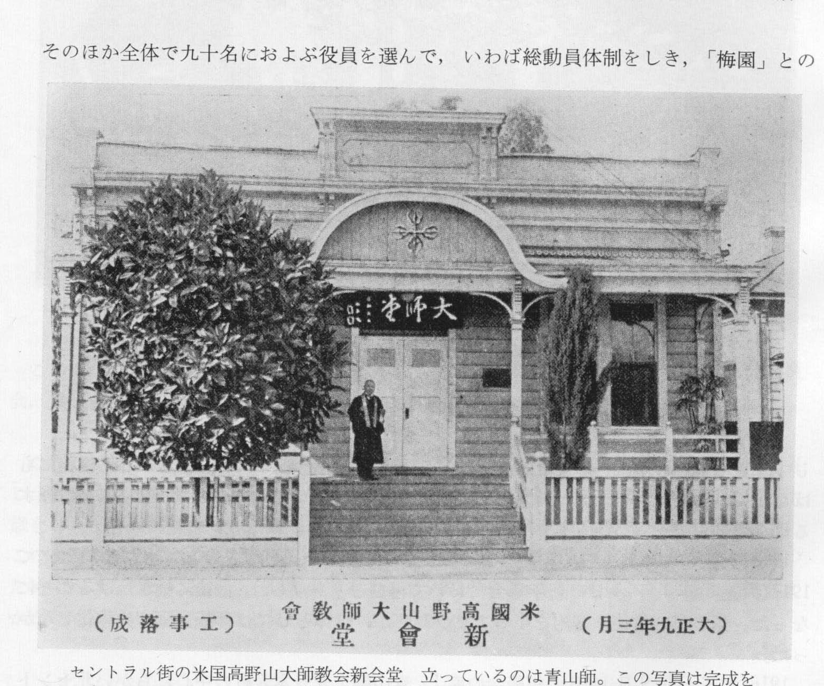
Rev. Aoyama with tree in 1920
In 1931, Reverend Taido Kitagawa formed Boy Scout Troop 379 as a way to help Japanese American children armor themselves against the anti-Japanese rhetoric of the early Depression. That same year, Reverend Seytsu Takahashi arrived, and after two years of oversight, Reverend Kitagawa transferred leadership of the temple to Reverend Takahashi. Despite the economic hardships of the Depression, the temple flourished under Reverend Takahashi. In February 1935, Troop 379 was named the outstanding Boy Scout troop in the United States by President Franklin D. Roosevelt, and the scouts traveled to Washington, D.C.

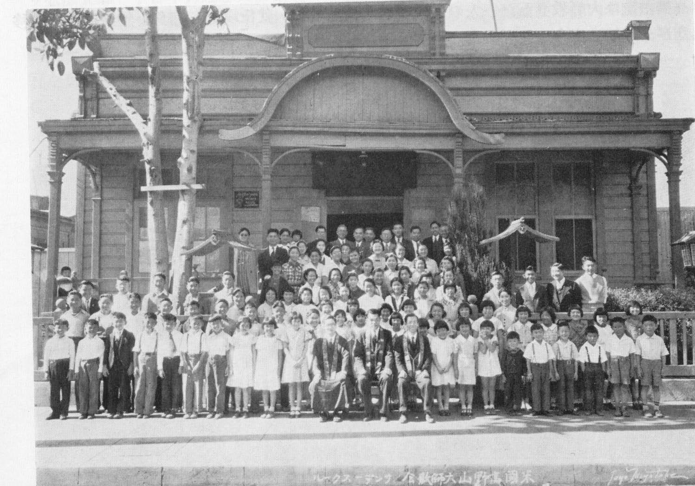
In 1937, Koyasan purchased a lot at 342 East First Street in Little Tokyo to build a new temple. The groundbreaking took place on November 17, 1939. The temple was designed by Mieki Hayano and built by the Cooper Construction Company. The temple, raised in status to Koyasan Beikoku Betsuin, officially opened on October 26th and 27th of 1940.
Koyasan Sunday School in 1935

The Japanese bombing of Pearl Harbor in December of 1941 disrupted the lives of the Koyasan congregants when all Japanese Americans living on the west coast of the United States were interned in War Relocation Authority (WRA) camps. The FBI detained Reverend Takahashi for the duration of the war in several different prisons and detention camps, including Crystal City, Texas. Koyasan’s Reverend Ryosho Sogabe, however, continued to minister to internees in various WRA camps, and Boy Scout Troop 379 continued to meet at Heart Mountain, Wyoming. During the war, Koyasan’s basement and hall were used to store the internees’ goods. Following the return of Japanese Americans to the west coast, Koyasan reopened the temple as a hostel.

A sign that the temple was beginning to recover from the painful internment period came in 1949, when the Sonenkai, or Young Buddhist Association, was formed at Koyasan Temple. Following the geographical dispersal of the Japanese American community, Koyasan built the Harbor City Church and a Japanese language school in 1955.

Koyasan Temple is currently the home of the Hiroshima Memorial Park peace flame, and holds a memorial service each year for the victims of the Hiroshima and Nagasaki atomic bombs. The temple remains the home of Scout Troop 379 and continues to be a vibrant center of Japanese American life and worship in Little Tokyo. The congregation is looking forward to celebrating its centennial in 2012.

Koyasan’s former building at 133 N. Central was occupied by the Osaka Kenjinkai (a Japanese prefectural organization) and what may have been a martial arts league, sometime between 1940 and 1950. In the early 1950s, the building was razed by the City of Los Angeles to build the parking structure and lot for the Los Angeles Police Department’s Parker Center. The Aoyama Tree, however, was left undisturbed and stands as a tribute to the rich legacy of Koyasan Temple, Buddhism, and Japanese American history in Los Angeles.

For information about Koyasan Buddhist Temple, please visit: www.koyasanbetsuin.org

For information about Little Tokyo Historical Society, please send email to: lthistory@gmail.com

